Hero Combat Simulator

1.8.8

Table of Contents

Hero Combat Simulator Tutorial 3
Using the HCS Character Editor 9
Saving a character 9
The Power of Rosters 10
Manipulating Rosters 10
Adding Characters to a Roster 11
Working with Combat Profiles 11
How to Access the Combat Profiles 12
Importing from Hero Creator, Creation Workshop & Metacreator 12
HCS-specific tags 13
Loading the Tag file 13
Using the HCS Tags 13
Importing a character 14

Hero Combat Simulator Tutorial

The following document provides a brief tutorial to illustrate simple combat in the Hero Combat Simulator or HCS software. Screenshots have been provided to explain pertinent areas of the HCS interface so that simple and efficient Hero System combat can be achieved. This chapter is not meant to explain all of the advanced features of HCS, it is intended as an introductory tutorial to begin to reveal the power of HCS.

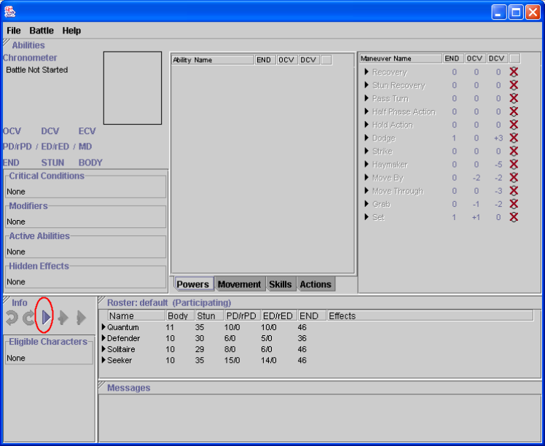The first step is to launch HCS. For this beta release this software can only be installed on Windows products (Windows 95, 98, NT, 2000). Other OS users should contact pruttm@yahoo.com to discuss how to get it to work for your OS. In the future we will include an installer for other betas. So, go to your Windows Start Menu and choose the Hero Combat Simulator folder and select the application called Hero Combat Simulator.

After HCS has initialized its components it will bring up a default screen divided into four panes. The panes that make up the screen are mostly empty or grayed out. This is because the battle hasn’t started yet. Look on the screen for the control that looks similar to VCR controls and select the “play” button. It is circled in red on the screenshot. Once the battle has started, notice how much of the screen is now filled out. The battle has begun.
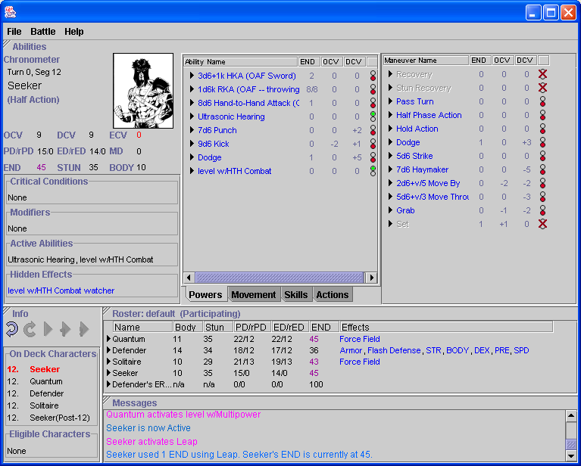
Now before actual fighting can occur the default panes need to be described and their purpose needs to be explained.

There are four main panes in the default window that make up HCS. The top pane is the Abilities pane. This pane contains three sub-panes within the Abilities pane. The right most is the Active character sub-pane. It holds information for the active character including his name, his pertinent stats (OCV, DCV, BODY, etc), his picture and the state of his various abilities. As you can see the states are divided into Critical Conditions, Modifiers, Active Abilities and Hidden Effects. Critical Conditions will house important information like if the character is knocked down or unconscious. Modifiers will list the powers that are currently modifying the character. Things like force fields, armor and other active character generated effects are here. Under Active abilities the user would see a list of all of the abilities that the character is currently running like combat levels, damage classes as well as most of the active character generated effects. Hidden Effects would include effects that are mainly listed during the beta process of HCS. In the end, these will most likely be masked from the user. The middle sub-pane has four tabs: Powers, Movement, Skills and Actions. Under the Powers tag is a list of powers that the active character has available. There are five columns underneath this tab: Ability Name, END, OCV, DCV and ST (currently not labeled). The Ability Name column lists the powers currently possessed by the active character. Those powers that are not active because of a lack of necessary endurance or a specific Hero ID isn’t active will be grayed out and a red X will be placed in the ST column. The END column will contain either the amount of endurance that the power uses for one use of the power or if the power has charges then the number listed will be the number of remaining charges. The next two columns list the OCV and DCV changes that activating this power will have on the active character. Currently, martial maneuvers are listed under Powers and so these columns have a lot of value for those types of maneuvers. In the future, these columns may be removed from the powers tab. Finally the ST column graphically shows the current state of the power. Active powers will have a green light, inactive powers will have a red light and powers incapable of being activated will have a red X in this column.

Next comes the Info pane. The Info pane houses the clock so that the user can keep track of what turn and segment it is. It keeps track of the Active Character, the character that is currently able to make an action. Also tracked in this pane are the characters that are next in order to become active, these characters are called On Deck Characters. Lastly, this pane lists the characters that are eligible to take an action listed in the Elegible Characters field. These characters are generally characters that have a held action and can be selected to become the active character.

The next pane is the Roster pane. It holds all the characters that are in the battle. Each character will be listed with some default information about that character like Body, Stun, PD etc. Under the Effects column, various powers that are constant or persistent (and turned on) are listed here. Force field, armor, flash defense and many others are commonly listed in the Effect column for a character. The Effects column will also contain some important states that the character is currently in like knocked down, stunned, unconscious, etc. There is some duplication with what’s tracked in the active character area of HCS, but that is mostly due to the fact that a user may want to see the state of a non-active character. Generally, the active character sub-pane is the place to go to understand the state of an active character at a glance.

The final pane is the Message pane. This is like a message board for changes that occur as HCS is used. When combat is started, persistent powers will be started and this will be noted in the Message pane. Detailed information on hit outcome, damage and knockback are also recorded in this pane.

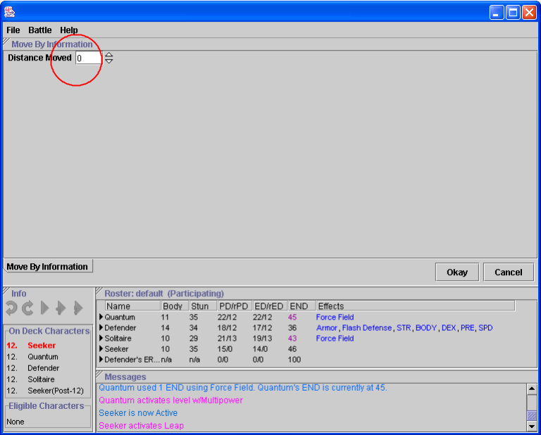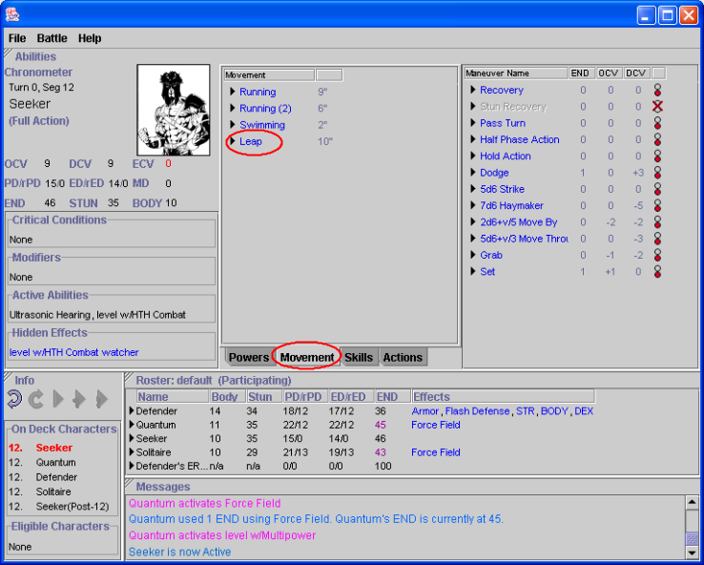Now on to battle! The active character is Seeker. Since Defender is his enemy in their training session, he has decided to leap up to him using a half move and sock him in the face. To initiate the leap, first click on leap in the Ability pane under Movement column. You will see that the contents of the Ability pane change and new information comes up specific to the movement power running. The options for each ability will be processed within the Ability pane area. In HCS, a pane that changes its contents as it processes the options for movement or an attack is called an inline pane. Currently, the only inline pane is the Ability pane but it is possible that more of the default panes will have inline capabilities in the future.

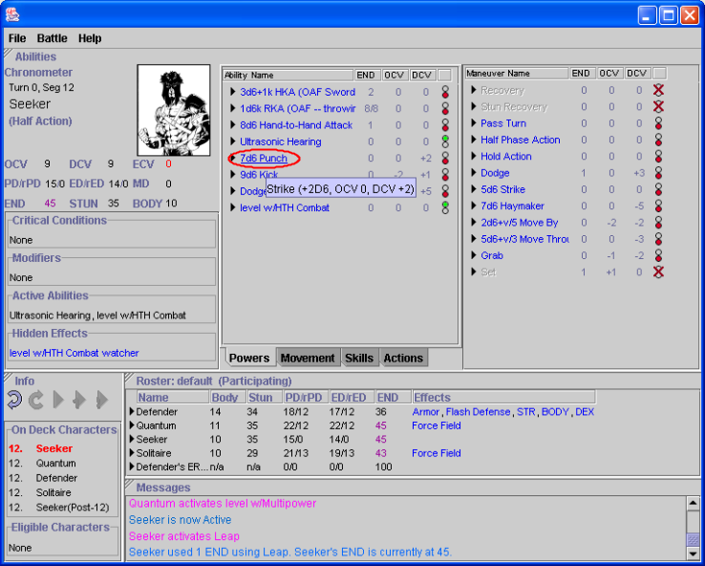Now, the updated Ability pane shows a field where you can type in the distance moved. Type in 5 and select the okay button. HCS now processes the movement and sends an informational message to the Message pane that the movement power was activated and, in this case, that END was deducted from the character’s statistics.

Now Seeker has a half move left and wants to punch Defender with his Martial Strike. Do this by selecting the punch maneuver in the middle ability. Once that is selected, a message will be logged to the Message pane and the Ability inline pane will update with options for the Martial Strike maneuver.

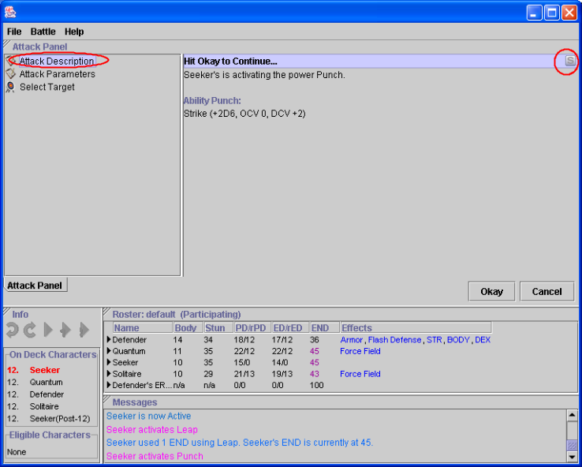

The attack process is a group of inline panes that can be set to be skipped or viewed every time the attack is initiated. Before committing the attack skipped panes can be reviewed and changed. For more information on setting up the panes you will like to see, look at the chapter on Combat Profiles. In this example, all of the panes will be viewed.

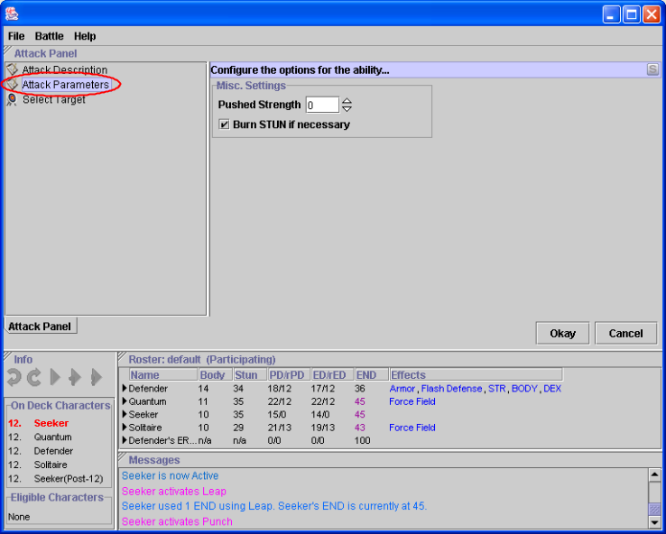The first pane is the Attack Description pane. It lists information about the activating ability and its configuration at creation time. Generally, this pane is skipped. However, for those powers that activate again and again, this pane will allow you to easily understand why it is coming up.

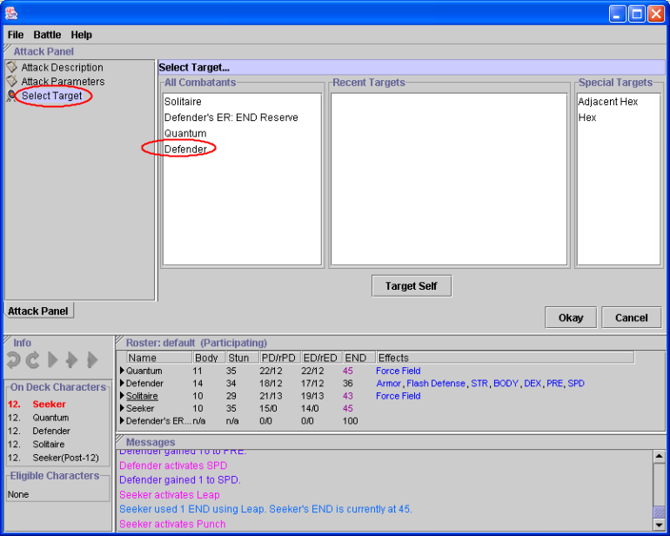

The next pane is the Attack Parameters pane. It allows you to set various options for this use of the ability. For punch, Seeker could choose to push his strength. Select the Okay button to begin the attack.

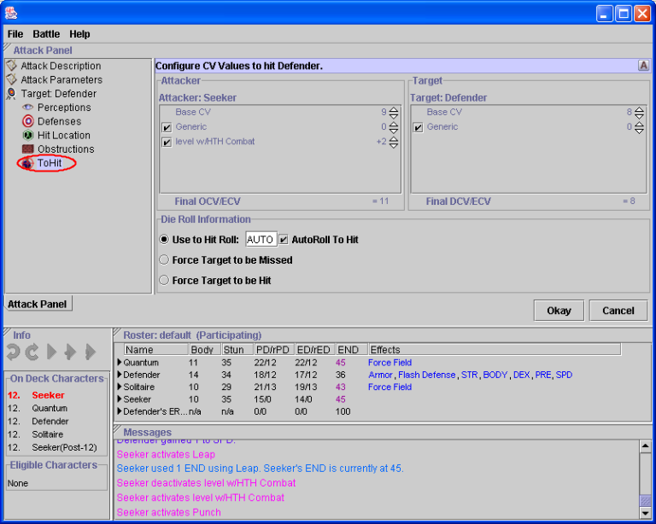Following the Attack Parameter pane comes the Select Target pane. Here the attacker can select a target including hexes and himself.

Again, Seeker is punching Defender so click Defender in the All Combatants window.

Once Defender is clicked on, the Ability inline pane will update again and the ToHit pane will appear. Here choices to resolve the attack roll that Seeker needs to make to strike Defender. The Attacker: Seeker column shows Seeker’s base OCV as well as the 2 combat levels that he has with Martial Arts giving him a total of 11 OCV. The Target: Defender column shows that Defender has a base DCV of 8 without any special modifiers at this time. Both columns offer a generic option so that the user can modify both characters’ Combat Value due to special circumstances.

Under those boxes is a third box called Die Roll Information. This is where the user would type in the roll made by Seeker’s player on 3D6 or allow the roll to be autorolled. Autoroll is on by default, but to enter a manual roll just uncheck the box and type in your roll. Click on the Okay button when this is complete.

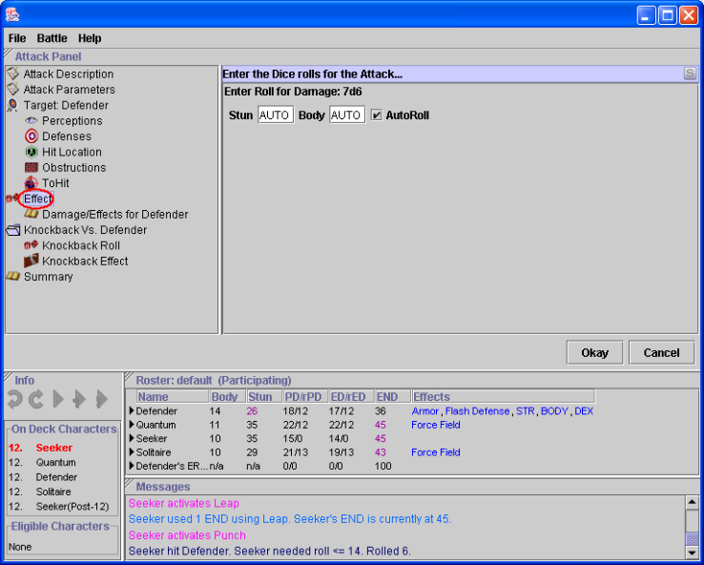

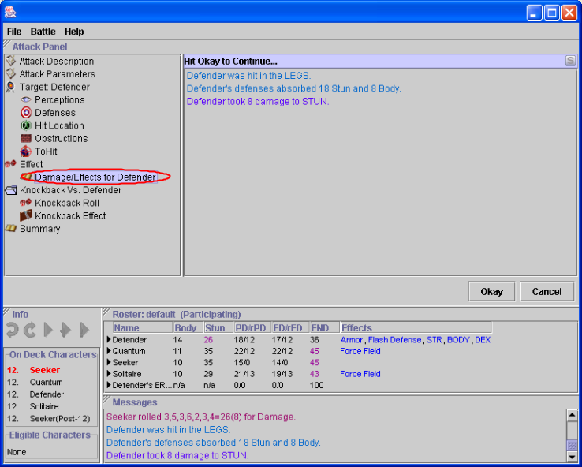Once again the Ability inline pane changes and the Effect pane will appear. Here HCS is now offering the option to either autoroll the damage for the attack or allow the user to uncheck the Autoroll checkbox and type in the STUN and BODY. Choose Okay after deciding which option to select.

Next, the Damage Effects for X pane will appear. This is just an informational screen describing the outcome of the Effect pane. In this case it lists the damage done by Seeker’s attack on Defender.

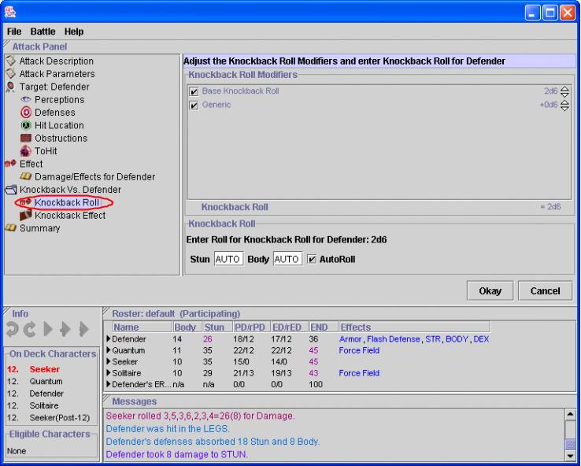After that, the Knockback Roll screen will arrive beginning the final stage of attack processing. Knockback is on by default in HCS, but it can be turned off by selecting the File | Preferences… menu item and then choosing the Optional Rules tab. Uncheck Knockback Enabled to turn it off.

As with all dice options in HCS, the user can either allow HCS to autoroll the dice for knockback or it can be typed in manually in the Knockback Roll boxes. The only modification you can make at this point to knockback is to account for the target. Examples of when you would change the Knockback Roll Modifiers on this option are, for example, when the

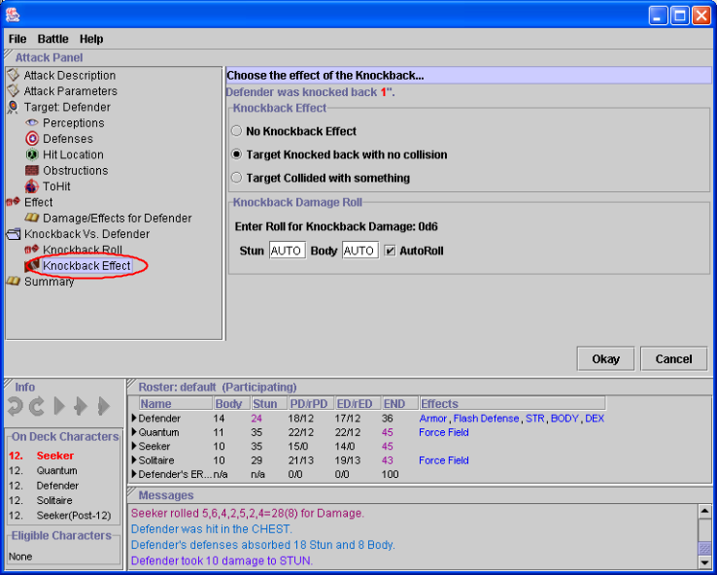

target is underwater or flying. Click on the okay button when you are finished adjusting the knockback modifiers.

Then the Knockback Effect pane will appear. As you can see, Defender was knockbacked back one hex by Seeker’s punch. The screen can also be configured to disregard knockback or to allow for the target to collide with a structure. The user also needs to autoroll the damage or type it in and hit okay.

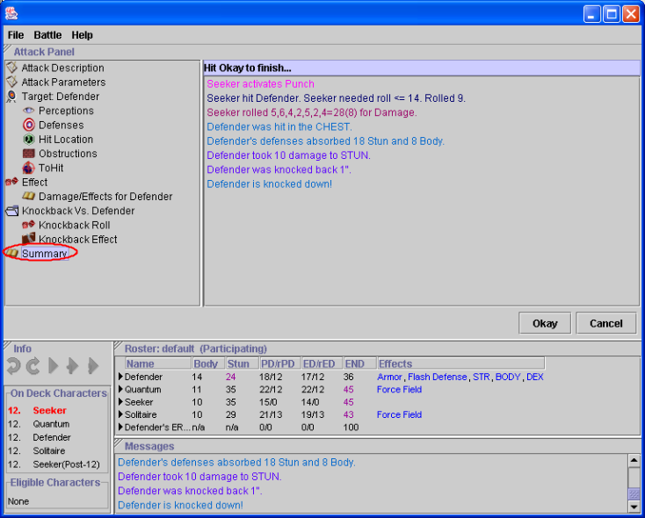Finally, the Summary pane will appear. This will summarize all of the previous panes into a screen that describes what happened during the attack.

So that’s it. That’s the basics of how an action phase goes for a character. There are other features that you will find as you experiment with other powers and maneuvers. HCS can handle spreading, AE, autofire and many other options. Enjoy the beta!

Using the HCS Character Editor

HCS has a Character Editor so that you can create or modify characters for use within HCS.

Note: There are some definite column formatting issues in the CE that will eventually be taken care of but for now just move the columns around as you see fit to get done what you need to do.

There are three main areas of the CE. From the right is the Stats pane. In this pane is the Name of the character and the stats at creation time called Base Stats and the stats during a battle called Current Stats. This like Growth, characteristics as powers and adjustment powers will be reflected in the Current Stats. Toggle between the two by clicking on the toggle button in front of the type of stats you want to view.
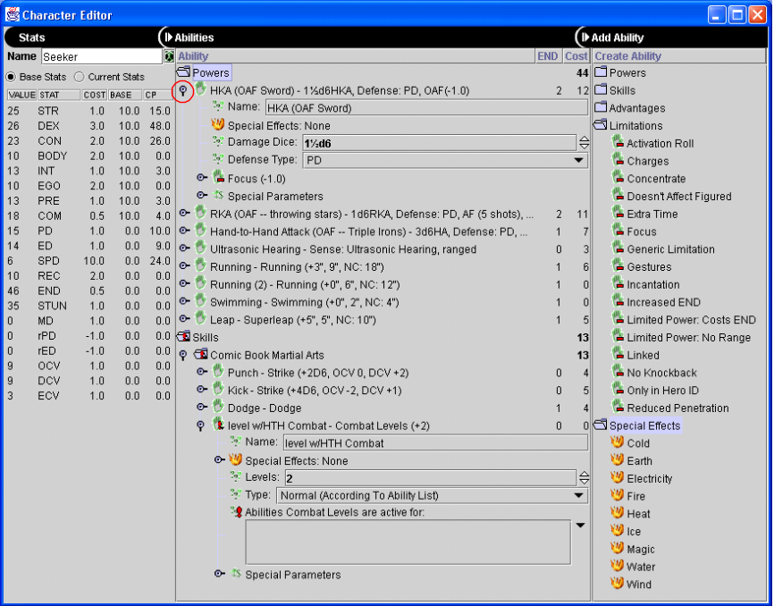The middle pane in the Ability pane. Here you will see listed all the Powers and Skills that the character possesses. To illustrate how the powers are defined in HCS, you will see that Seeker’s HKA Sword has been opened from in the tree by clicking on the toggle arms (see one circled in red). These toggle arms will allow you to drill down into the power. The last pane is the Create Ability pane. Here you can add Powers, Skills, Advantages, Limitations and Special Effects to the character. Open the folder by clicking on it and then click or drag a component into the Abilities pane.

Saving a character
Right-click in the CE and select Save Character As… or Save Character. Then a request for file name and location will appear. Click Okay when finished.

The Power of Rosters
One of HCS’ most powerful features is its ability to group the characters that are in HCS into separate Rosters. These Rosters can help you organize which characters are with which teams. It can also allow you to save the group together so that you don’t have to load one character at a time every time you launch HCS.

Manipulating Rosters

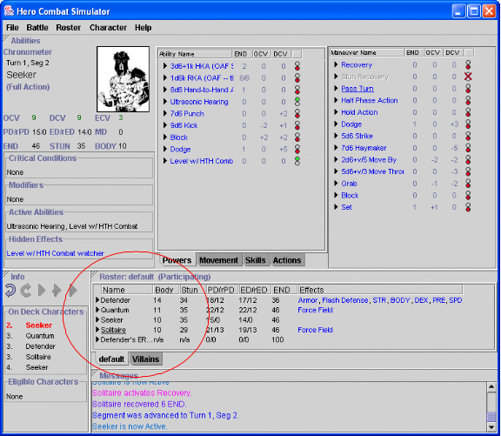Rosters appear in the Roster pane (circled in red). Once you have added multiple Rosters to a session you can access them by the tabs at the bottom of the Roster pane. The picture shows the default Roster as well as a new Roster called Villains.

The Roster Menu options can be selected from the Right-Click menu when your mouse is pointing in the Roster pane. The first two options listed below are also available from the Main Menu under Rosters. The options are as follows:

New Roster
Select this to make a new Roster. NOTE: You must select Save Roster As to actually save a permanent file otherwise the new roster just exists for the current HCS session.
Open Roster
Select this to open an existing Roster. Browse the file system to open your Roster file. Roster files end with the extension .RST.
Save Roster
Saves a Roster that has a file already but you have updated it in the current session of HCS.
Save Roster As
Saves a Roster that does not have an existing file.
Close Roster
Closes the Roster you are currently displaying.
Add to Battle/Remove from Battle
Rosters can be part of the current battle, just be open in HCS for reference or for adding to the battle later in the session. You can tell if a Roster is in the battle by looking at the title of the battle in the Roster pane. If it says ‘Participating’ it is part of the battle. If it says ‘Not Participating’ it is not part of the battle. Choose either Add to Battle/Remove from Battle to change the participation of the Roster in the battle. Note: it is generally not a good idea to remove a Roster from a running battle at this time.
Roster Profile
This option allows you to assign a Combat Profile to this Roster. Combat Profiles are covered in a later chapter.

Adding Characters to a Roster
It is very easy to add characters to a Roster. First makes sure you have selected the proper tab so that the title of the Roster you want appears in the title bar. Then, from either the Main Menu or the Roster pane right-click menu select Open Character or New Character. With Open Character you will be prompted to select a file and then that character will appear in the Roster. By selecting New Character a blank character will appear in the Roster awaiting configuration. You can also select Remove Character from the right-click menu when your mouse is pointing at a specific character.

Working with Combat Profiles
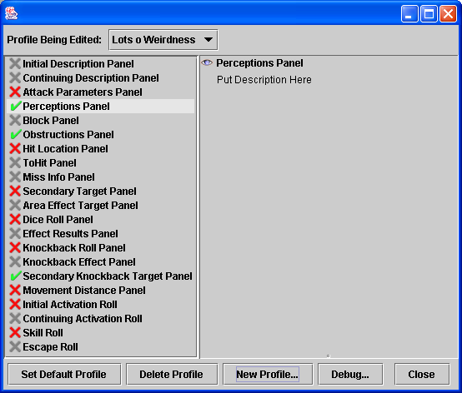
Combat Profiles are a feature of HCS designed to allow you to suppress as much of the attack process as you want. As described during the tutorial chapter, you discovered that there are a lot of panes in the attack process like ToHit, Hit Locations, Obstacles, etc. HCS has a Default Combat Profile that turns on a number of critical screens like the ToHit but leaves a number of the more information intensive ones off. The user has the ability to change the Default Combat Profile or add additional Profiles. These additional Profiles can be added directly to Rosters. Characters also have a built-in Combat Profile that can be edited for those characters that need a special tweak. The Default is applied to all profiles no matter what. HCS checks from most specific (a character) to group specific (a Roster) to least specific (Default Combat Profile). So, HCS looks at the character first, then the character’s Roster and finally the Default Combat Profile to determine whether to display a particular pane or not for each character. There are three states that a pane can be set in:

- Displayed
- Default Skipped but other Profiles in the chain can override
- Skipped and no override is allowed

If you set the icon then any less specific Profile cannot force the Pane to be skipped. So, if you set a pane to be displayed in the Character Profile using the icon it cannot be skipped by settings that same pane with the icon in a Roster Combat Profile or the Default Combat Profile. If you want to allow a less specific Profile to determine whether the pane is displayed or not use the icon. This would allow you to have a Character Combat Profile to turn on a certain pane or two but would allow every other pane’s display to be determined by the Roster or Default Combat Profiles. Finally, if you want to block less specific Profiles from displaying a pane no matter what, set the pane with the icon. This is useful for NPCs. Say you want to have a Roster of NPC characters that you only want a summary for every attack. Mark every item in the Roster Combat Profile with a icon and you will block all the settings from the Default Profile. A NPC Roster Combat Profile has been included in the distribution for your convenience. Apply it to any NPC groups to suppress all panes except the summary at the end of the attack.

How to Access the Combat Profiles
Combat Profiles are located in two locations. The first is on the Main Menu bar under the Character Menu. Select Edit Combat Profiles and the window shown above will appear. Here you can edit the Default Combat Profile as well as make Roster Combat Profiles by selecting the New button. You can also make a different Profile default by clicking on the Set Default Profile button.

To edit a Profile you select it from the drop-down box labeled Profile Being Edited. Once you’ve selected the Profile you want to edit. You can click on the icon of the pane you want to modify until the icon you want is displayed. Continued clicking will cycle through the three options indefinitely.

To Access the Character Combat Profiles, you will need to open up a Character Editor screen for that character and from the Character menu select Edit Character Combat Profile. Here you can toggle the same icons. There is no Profile to select so just make the changes and close the window.

Bug Alert! There is a current bug with the Combat Profiles where the Roster Combat Profile doesn’t always take effect immediately. To workaround this problem, always set up your Rosters, load your characters, set the Combat Profile and save the Roster. Then restart HCS.

Importing from Hero Creator, Creation Workshop & Metacreator

It is possible to import Hero System characters created from these packages into HCS. For ease of understanding, this document will refer to all three of these packages as Creation Workshop or CW. Importing of characters from CW is a one-way process. This means that you cannot make modifications to the character in HCS and have the changes appear in the imported file. While HCS does have a character editor we are going to support CW as the main character editor for HCS. We are handling it this way so that you can get access to the wonderful printing capabilities of CW. So it is best to create all your characters in CW and then import them into HCS. This is especially important during the beta phase since as new releases of HCS are distributed HCS character files may become invalidated and require a re-import.

We have also included add-ons to CW to make it better support special needs of HCS. Note: We have in no way modified any of the shipping components of CW.

HCS-specific tags
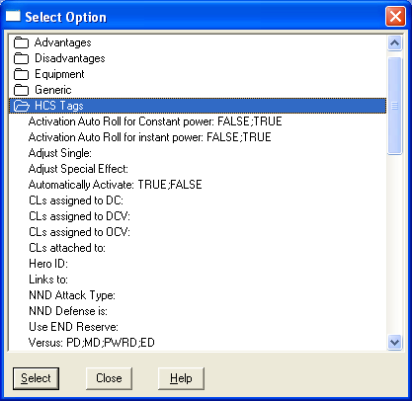
HCS-specific tags are available in Creation Workshop to help make the imported character be more complete for use within HCS. Things like setting the END Reserve and setting a power to automatically activate at the beginning of the battle are supported. See the graphic for the currently available Tags.

Loading the Tag file
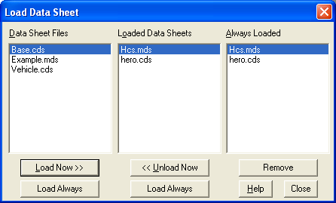
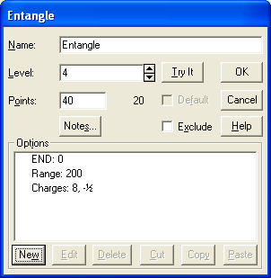
We have included a CW .mds file called HCS.mds. This file has all the tags and will need to be loaded into CW when you make your characters. To load this file, launch CW and select Load Data Sheet from the File menu. You should see HCS.mds in the Data Sheet Files pane. Select HCS.mds and click the Load Now button. It should now appear in the Loaded Data Sheets directory. Next, click the Load Always button. HCS.mds should now appear in the Always Loaded Directory. Your tags are now available, click the Close button.

Using the HCS Tags
HCS tags are as easy to add to a characters as Advantages or Limitations. Just make a new power like you normally do and then hit the New button. The familiar Select Options window will appear where Advantages, Limitations, etc. normally are available. In addition to these you will now have new folder in the list called HCS Tags. Click on this folder to expand the list of Tags that are available.
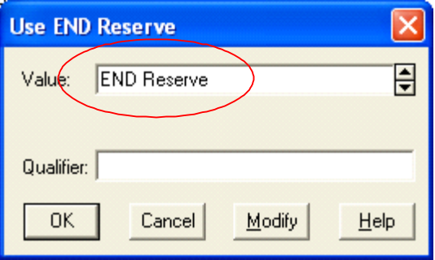Add the Tag to the character and file out the text space (Circled in Red) with the exact spelling of the information needed and close the window or select TRUE or FALSE. If you are typing in the name of a power put the exact name of the power into the text space like shown in the graphic.

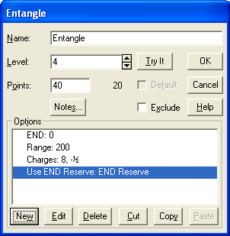
The new Tag will now appear in the Options pane of the power. When you learn how to export the character in a later chapter your tag will now be recognized by HCS and set the Tag feature in HCS.

Importing a character
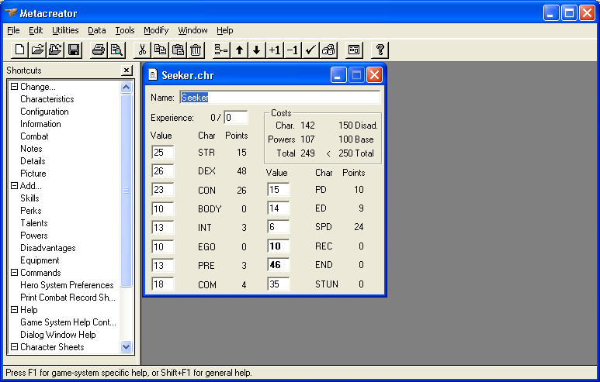
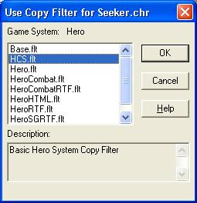
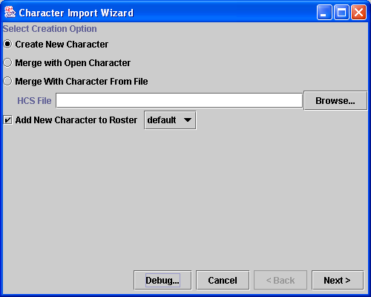
Launch CW and open a Hero System character. Then go to the CW menu and select Edit | Filter Copy. Assuming you installed HCS with the filters you will see a selection in the filter list called HCS.flt. Highlight it and select OK. Now the CW character has been run through a filter that creates text importable by HCS. It has been copied to your clipboard and is available to HCS. Now go back to HCS and go to its menu and select File | Import Character. You will see the Select Creation Options window. Here you have the Options to Create New Character, Merge with Open Character (broken), and Merge With Character from File (broken). For now just go with the Create New Character option and then decide whether you want to add this character to a roster or not. All loaded rosters will appear in the drop down box next to the Add New Character to Roster option. Click Next to continue.

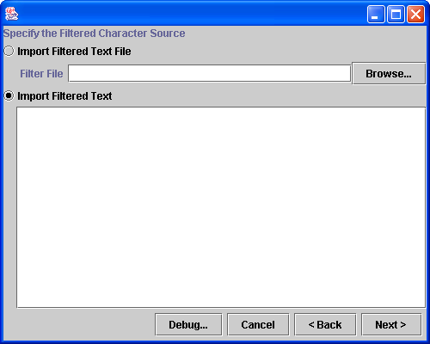
The next screen allows you to get the filtered text from CW into HCS. There are two ways to enter the text into HCS. Import Filtered Text file is the first. While this will work it is not a recommended method in most cases. Go with the default of Import Filtered Text. Type CTRL+v on the keyboard and the filtered text should appear in the large window. Select Next to continue.

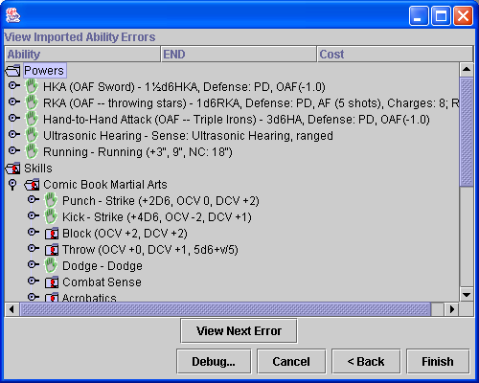
The next window to appear is the View Imported Ability Errors. This window allows you to look through the imported character and see what was understood. Things marked with an exclamation mark are going to be ignored or need attention. Click Finish to complete the import. The Character Editor will now appear for final adjustments. Please see the Character Editor section for more.

